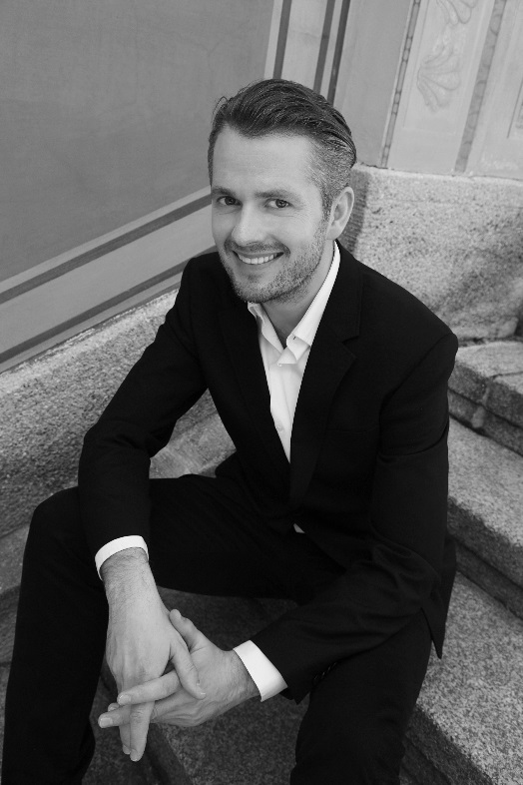

Karol Kozłowski
tenor

Graduated from the Academy of Music
in Gdańsk ( MA in Singing and Drama
with distinction, 2007 ) where he studied
with dr Stanisław Daniel Kotliński. He is also a graduate of the Faculty of Sculpture
at the Academy of Fine Arts in Warsaw. Participated in master classes of Ryszard Karczykowski, Rolando Panerai, Salvatore Fisichella, Sylvia Geszty, Helena Łazarska and Claudio Desderi. He was awarded the second prize at the Hariclea Darclèe International Voice Competition (Romania, 2005). Karol Kozłowski has also been a nominee for the 2013 Polityka’s Passport Award for classical music and together with pianist Jolanta Pawlik for the 2013 Fryderyk Award in the category: chamber music – the artists recorded a cycle of F. Schubert’s songs Die schöne Müllerin (DUX, 2012).
In years 2007- 2009 he was a soloist of the Wrocław Opera, where he debuted as Alfred in Die Fledermaus (The Bat) by J. Strauss, and sung also the part of Tamino in The Magic Flute by W. A. Mozart, Count Almaviva in The Barber of Seville by G. Rossini, Cassio in Otello by G. Verdi and Archangel in Paradise Lost by K. Penderecki. Karol Kozłowski has sung on the stages of the Théâtre Montansier in Versailles (Oebalus in W. A. Mozart’s Apollo et Hyacinthus), the Latvian National Opera in Riga (Count Almaviva in G. Rossini’s The Barber of Seville), Staatstheater am Gärtnerplatz in Munich (Lindoro in G. Rossini’s L'Italiana in Algeri) and of the Kyiv Opera (Edrisi in K. Szymanowski’s King Roger). Since 2009 he has collaborated with the Teatr Wielki – Polish National Opera, where he has has been featured as Vitellozzo in G. Donizetti’s Lucrezia Borgia, Misail in M. Musorgski’s Boris Godunov, Damazy in S. Moniuszko’s The Haunted Manor, Young Servant in R. Strauss’ Elektra, Kudryash in L. Janaček’s Katya Kabanova, Edrisi in K. Szymanowski’s King Roger, Goro in G. Puccini’s Madame Butterfly, the Dancing Master and the Lamplighter in G. Puccini’s Manon Lescaut and Father Mignon in K. Penderecki’s The Devils of Loudun.
Since 2010 Kozłowski has been a soloist in the Capella Cracoviensis early music ensemble. Together with Capella Cracoviensis he has performed Monteverdi’s music (in the m.m.m.bar.okowa uczta project), Haydn’s Stabat Mater, Requiem and The Great Mass in C minor by W. A. Mozart. He has also sung J. S. Bach’s Magnificat as well as the Evangelist’s part in Bach’s both St John Passion and St Matthew Passion. He has cooperated with such directors as Fabio Bonizzoni, Andreas Spering, Andrew Parrott, Konrad Junghänel, Kai Wessel, Christophe Rousset and Jan Tomasz Adamus. He participated in concert performances of G. F. Haendel’s operas, where he sang Bajazet in Tamerlano and Lurcanio in Ariodante. He has collaborated with major polish baroque music ensembles, performing on authentic instruments i.a. Wrocław Baroque Orchestra, The {oh!} Orkiestra Historyczna, Musicae Antiquae Collegium Varsoviense, Il Giardino d’Amore and Arte dei Suonatori.
His voice’s exceptional timbre and versality has inspired also living composers. Since 2012 Kozłowski has regularly participated in the Kissinger Sommer Festival in Bad Kissingen, where parallel to the masterpieces of Romantic and 20th century art song, accompanied by such outstanding pianists like Melvyn Tan, Axel Bauni and Jan Philip Schulze he has performed the world premiere pieces for voice and piano, written especially for him by i.a. Oliver Schneller, Manfred Trojahn and Bernd Redmann. In 2014 composition of Andrzej Kwieciński- Canzon de’baci for tenor and orchestra, performed for the first time in Katowice a year earlier during the 6th Festival of Premieres (Karol Kozłowski was accompanied by AUKSO Chamber Orchestra of the City of Tychy under the baton of Marek Moś) won the 61st International Rostrum of Composers in Helsinki. The artist’s tenor voice inspired Paweł Mykietyn- one of the most eminent composers of contemporary music – to cast Karol Kozłowski as Settembrini in his new opera The Magic Mountain. The world premiere, directed by Andrzej Chyra took place at Malta Festival 2015 in Poznań.
www.karolkozlowski.eu

